Supplementary Materials: Cloning and Expression Analysis of MEP Pathway Enzyme-encoding Genes in Osmanthus fragrans

Chen Xu, Huogeng Li, Xiulian Yang, Chunsun Gu, Hongna Mu, Yuanzheng Yue and Lianggui Wang
Table S1. Primers used for partial cDNA cloning
Gene name | Primer sequence (5′-3′) | PCR condition
OfDXS1-F | GATGGCTCTCTTTACACTTGC | 94 °C 3 min, 30 cycles of (94 °C 30 s; 61 °C 30 s; 72 °C 2 min), 72 °C 10 min
OfDXS1-R | AGCCAGAGTCCATCCTAAGAC
OfDXS2-F | CGGTCCTGATCCATATTGT | 94 °C 3 min, 30 cycles of (94 °C 30 s; 58 °C 30 s; 72 °C 2 min), 72 °C 10 min
OfDXS2-R | TAGAGCTTCTTTGGGCCTT
OfDXR-F | TGACTGGTAGTAGAGTGACACAC | 94 °C 3 min, 30 cycles of (94 °C 30 s; 61 °C 30 s; 72 °C 2 min), 72 °C 10 min
OfDXR-R | CAACTCATACAAGAGCAGGAC
OfMCT-F | GCCAAAGCAGTATCTTCCAC | 94 °C 3 min, 30 cycles of (94 °C 30 s; 62 °C 30 s; 72 °C 1 min), 72 °C 7 min
OfMCT-R | CAGCAAGTAACAAATCATCAGG
OfCMK-F | AGTCAACTGTGTTCATCTTC | 94 °C 3 min, 30 cycles of (94 °C 30 s; 51 °C 30 s; 72 °C 2 min), 72 °C 10 min
OfCMK-R | GACAACAAAGTACAACAGTC
OfMDS-F | ATGGCGACTTCAAACCAC | 94 °C 3 min, 30 cycles of (94 °C 30 s; 58 °C 30 s; 72 °C 1 min), 72 °C 7 min
OfMDS-R | CCTCGTAAGGAGAACCACT
OfHDS-F | AACGGTCGGGATTTGGAGTTG | 94 °C 3 min, 30 cycles of (94 °C 30 s; 65 °C 30 s; 72 °C 3 min), 72 °C 10 min
OfHDS-R | GCCCTTCTGCCCATAAACTTA
OfHDR1-F | TGTGGACTACTGTTGAAAAGC | 94 °C 3 min, 30 cycles of (94 °C 30 s; 60 °C 30 s; 72 °C 1 min), 72 °C 7 min
OfHDR1-R | ATTTTCCACTCCATACTTGCG
OfHDR2-F | TTGGAGCTGCTGTGGATGA | 94 °C 3 min, 30 cycles of (94 °C 30 s; 57 °C 30 s; 72 °C 1 min), 72 °C 7 min
OfHDR2-R | CGAGCCTCTGCTATTTCTTGTA
OfIDI-F | CGCCACTGATTCCGGTATG | 94 °C 3 min, 30 cycles of (94 °C 30 s; 62 °C 30 s; 72 °C 1 min), 72 °C 7 min
OfIDI-R | TCGGCTGCTTTGCTCAGAG
Table S2. Primers used for RACE reaction
Usage | Gene name | Primer sequence (5′-3′) | PCR condition
3′ RACE  Outer PCR | OfDXS1-3′OF | TTTGTGCAATCTACTCGTCCTTC | 94 °C 3 min,  20 cycles of (94 °C  30 s; 55 °C 30 s;  72 °C 2 min),  72 °C 10 min
3′ RACE  Outer PCR | OfDXS2-3′OF | TCTGTGCCATCTATTCGTCATTC
3′ RACE  Outer PCR | OfDXR-3′OF | AGGTCCATTTGTACTTCCTCTTG
3′ RACE  Outer PCR | OfMCT-3′OF | AATTTGCATTGCCCGGAAAGGAG
3′ RACE  Outer PCR | OfCMK-3′OF | TCCATTGGTTCTCATAAAGCCTC
3′ RACE  Outer PCR | OfMDS-3′OF | TTACACTTCCAGCAGAAACCTTC
3′ RACE  Outer PCR | OfHDS-3′OF | CGATGAATCCCAAGAAGAGTTTG
3′ RACE  Outer PCR | OfHDR1-3′OF | GGACTACTGTTGAAAAGCACAAG
3′ RACE  Outer PCR | OfHDR2-3′OF | ATGAAGAGACTGTAGCAACTGCT
3′ RACE  Outer PCR | OfIDI-3′OF | CTCTTGGATGAACTTGGTATTCC
3′ RACE  Inner PCR | OfDXS1-3′IF | AGTGATGGCTCCTTCTGATGAGGCTGAG | 94 °C 3 min,  30 cycles of (94 °C  30 s;60 °C 30 s;  72 °C 1.5 min),  72 °C 10 min
3′ RACE  Inner PCR | OfDXS2-3′IF | TGTAGCATACATGGCTTGTTTGCCCAAC
3′ RACE  Inner PCR | OfDXR-3′IF | GTGGTGCTTTTAGGGATTTGCCTGCTGA
3′ RACE  Inner PCR | OfMCT-3′IF | GTTCCTGCCAAAGCTACTATCAAAGAGG
3′ RACE  Inner PCR | OfCMK-3′IF | ATTGCCGCAGGTCGAGGACAGTATGATG
3′ RACE  Inner PCR | OfMDS-3′IF | ATCGAGGCTGTGAAGCTCACTCAGATGG
3′ RACE  Inner PCR | OfHDS-3′IF | CACAGGGACGATTTAGTCATTGGTGCTG
3′ RACE  Inner PCR | OfHDR1-3′IF | GTGTGCGATTACATTTTGGGTGGTGAAC
3′ RACE  Inner PCR | OfHDR2-3′IF | TGTTGAAGGGAGAAACAGAGGAGATTGG
3′ RACE  Inner PCR | OfIDI-3′IF | GATTACCTGCTCTTCATTGTTCGGGATG
5′ RACE  Outer PCR | OfDXS1-5′OF | GATATGACTGGTGCCCAACATCC | 94 °C 3 min,  20 cycles of (94 °C  30 s; 55 °C 30 s;  72 °C 2 min),  72 °C 10 min
5′ RACE  Outer PCR | OfDXS2-5′OF | GACGAATAGATGGCACAGAACGG
5′ RACE  Outer PCR | OfDXR-5′OF | TCCCGTAACTACTGTGACAGCGT
5′ RACE  Outer PCR | OfMCT-5′OF | ACTTCAAGACCTTCCCTGTTCAC
5′ RACE  Outer PCR | OfCMK-5′OF | ACATGAAAGAGCGACGCCAAATC
5′ RACE  Outer PCR | OfMDS-5′OF | GCCTCCTTGTGTGGGCTTACTTT
5′ RACE  Outer PCR | OfHDS-5′OF | CGCTTCTTTCTTTCCCTGCACTG
5′ RACE  Outer PCR | OfHDR1-5′OF | ACGTTGTGCCGGTATTGAGACCT
5′ RACE  Outer PCR | OfHDR2-5′OF | TCTCCTCTGTTTCTCCCTTCAAC
5′ RACE  Outer PCR | OfIDI-5′OF | GCCGACGGCATTTCTAAGTCAAC
5′ RACE  Inner PCR | OfDXS1-5′IF | TTGATCGTGTCCAAAAGAGGAGTCGGAG | 94 °C 3 min,  30 cycles of (94 °C  30 s; 60 °C 30 s;  72 °C 1.5 min),  72 °C 10 min
5′ RACE  Inner PCR | OfDXS2-5′IF | GTTCCACCACCCATTGCGGCATGAATAG
5′ RACE  Inner PCR | OfDXR-5′IF | TCACCTGGTCGGCAAGAAGAGTCACATT
5′ RACE  Inner PCR | OfMCT-5′IF | CCCAATAAGCCAACCATCCTTTAGGACC
5′ RACE  Inner PCR | OfCMK-5′IF | TCATACGCTACCTCCACTTTTCTGCCAG
5′ RACE  Inner PCR | OfMDS-5′IF | TATATCTGGAAGCCCCAATGCCCCCAAT
5′ RACE  Inner PCR | OfHDS-5′IF | CTCACTACCAAGAGCCACATTTCCAACC
5′ RACE  Inner PCR | OfHDR1-5′IF | TTACAGGACCTTCTGGTAGCCAGTTCTC
5′ RACE  Inner PCR | OfHDR2-5′IF | GTTCACCACCCAAAATGTAATCGCACAC
5′ RACE  Inner PCR | OfIDI-5′IF | GCTTAATACCACCCTCACCAGCATCTGC
Table S3. Primers used for qRT-PCR
Gene name | Primer sequence (5′-3′) | Amplification length
OfDXS1-qF | AGTCACCGAGAAAGGCAGA | 239 bp
OfDXS1-qR | GGAAGCGACGCAAGAAAA
OfDXS2-qF | GGGCATTTGATGTAGCATA | 208 bp
OfDXS2-qR | ATCCTTCCCTTACCAATCT
OfDXR-qF | CCTCAAATTCCAAGGTGGGT | 219 bp
OfDXR-qR | GGATTCTCCGCAACTATGTC
OfMCT-qF | CCTAAAGGATGGTTGGCTTAT | 214 bp
OfMCT-qR | TGATACATCGTCGGTTACTTC
OfCMK-qF | GTAGTAGTAATGCCGCCACA | 198 bp
OfCMK-qR | ATGGAACGTCAAAGGGTAGA
OfMDS-qF | GCTTGCTTTACACGGAACT | 200 bp
OfMDS-qR | CCGATAATCAGCGGATAAC
OfHDS-qF | ACGAAGCCATTACCCTACA | 214 bp
OfHDS-qR | TTGCTGCATGAACTCTGCT
OfHDR1-qF | GCTAGAAAACAATTCCCAA | 159 bp
OfHDR1-qR | TACCACAACATCACCCTTA
OfHDR2-qF | ACAATCGGAAGGGGTTT | 195bp
OfHDR2-qR | TTCTCGCCTCGTAAGCA
RAN-qF | AGAACCGACAGGTGAAGGCAA | 117 bp
RAN-qR | TGGCAAGGTACAGAAAGGGCT
RPB2-qF | CACCAAGCAAAGGACCAGCAAG | 216 bp
RPB2-qR | TCACCAGGGAGAAGAGGATCAAGTA
ACT-qF | CCCAAGGCAAACAGAGAAAAAAT | 143 bp
ACT-qR | ACCCCATCACCAGAATCAAGAA
Table S4. Conserved domain analysis for MEP genes
Gene | Size (ORF) | Characteristic domain
OfDXS1 | 2172 bp | 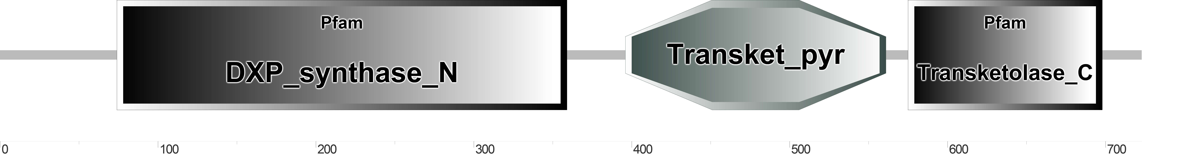
OfDXS2 | 2148 bp | 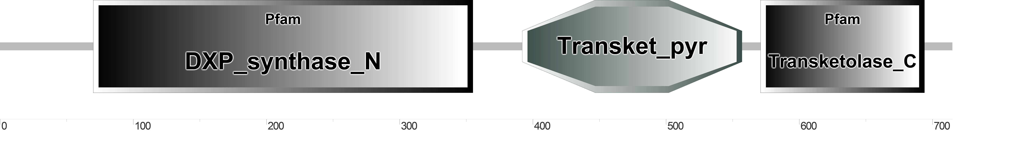
OfDXR | 1425 bp | 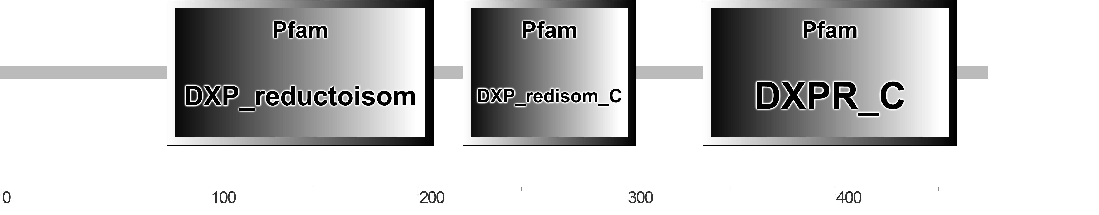
OfMCT | 939 bp | 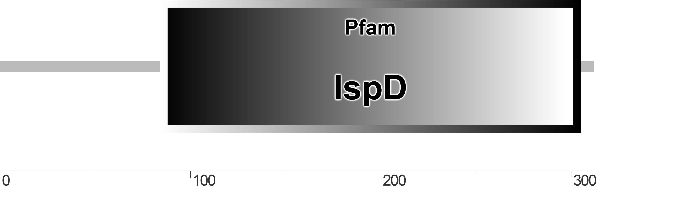
OfCMK | 1206 bp | 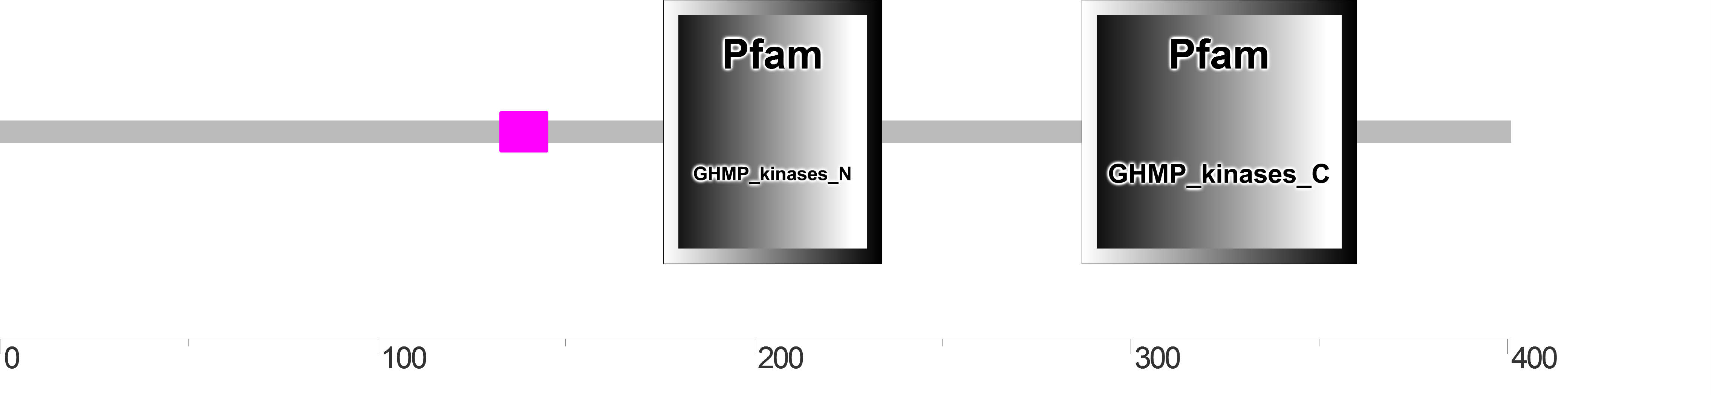
OfMDS | 702 bp | 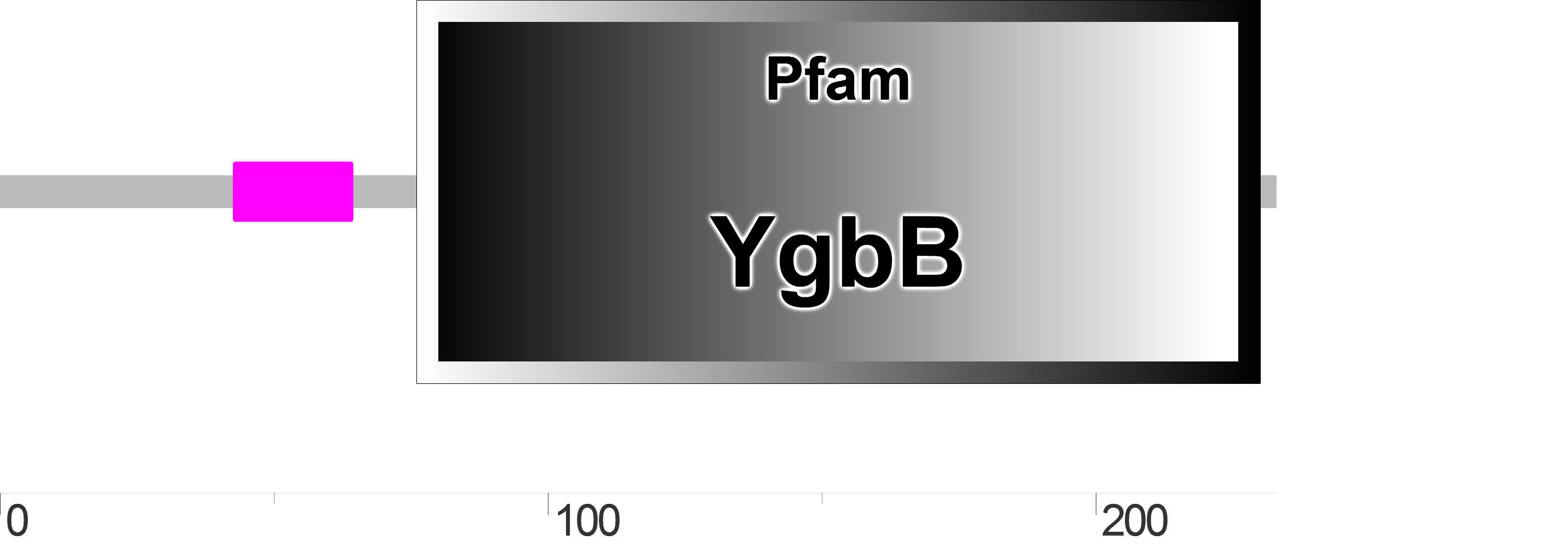
OfHDS | 2229 bp | 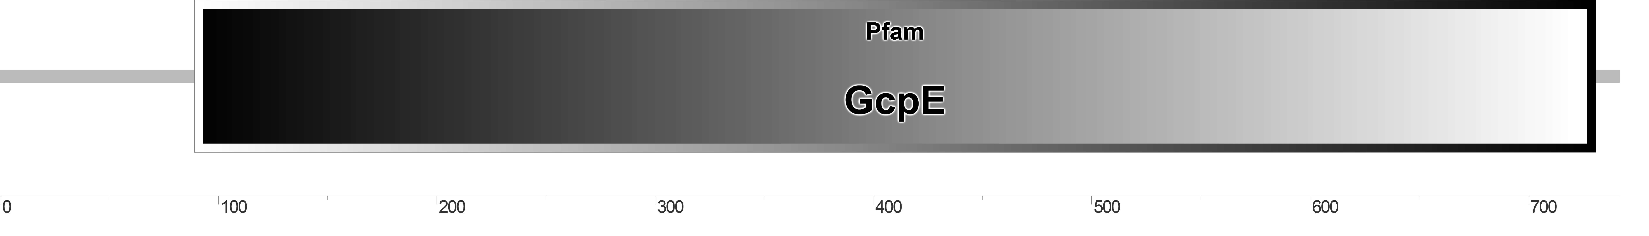
OfHDR1 | 1386 bp | 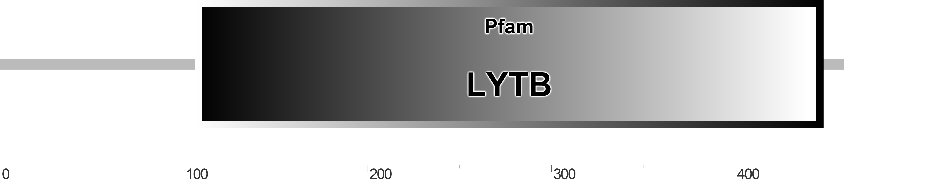
OfHDR2 | 1380 bp | 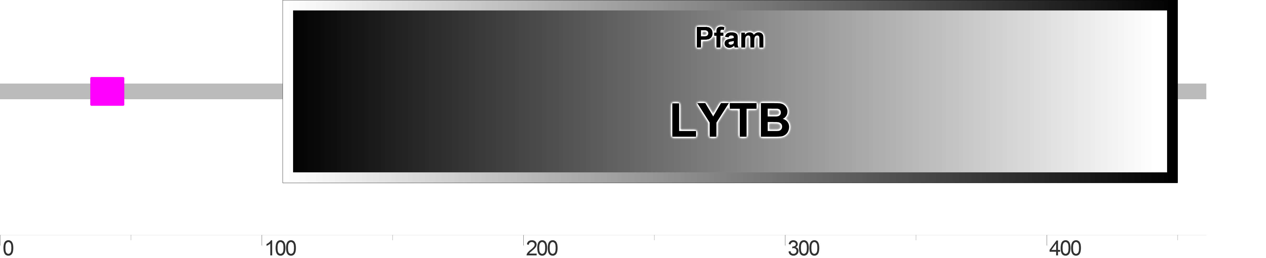
OfIDI | 708 bp | 